PRACTICAL TASK: L1 — Observe Organic vs Paid Results on Google

Open Google Chrome on your phone or laptop.
Search for: 'best jeans for men in India' and take a screenshot.
Circle / highlight all results that show the 'Sponsored' label — these are PAID ads.
Count: How many organic results appear on Page 1? (Usually 7-10)
Now search: 'apply for Aadhaar card online' — observe if any paid ads appear and why/why not.
Do this for 3 more searches of YOUR choice (something you searched this Module).
Submit: A screenshot of each search with labels identifying organic vs paid results.
Bonus: Check the same keyword on Bing — are the results similar or different?
ANSWER:-
- I opened google chrome on laptop.
- Searched best digital marketing classes in Ahmedabad.
- 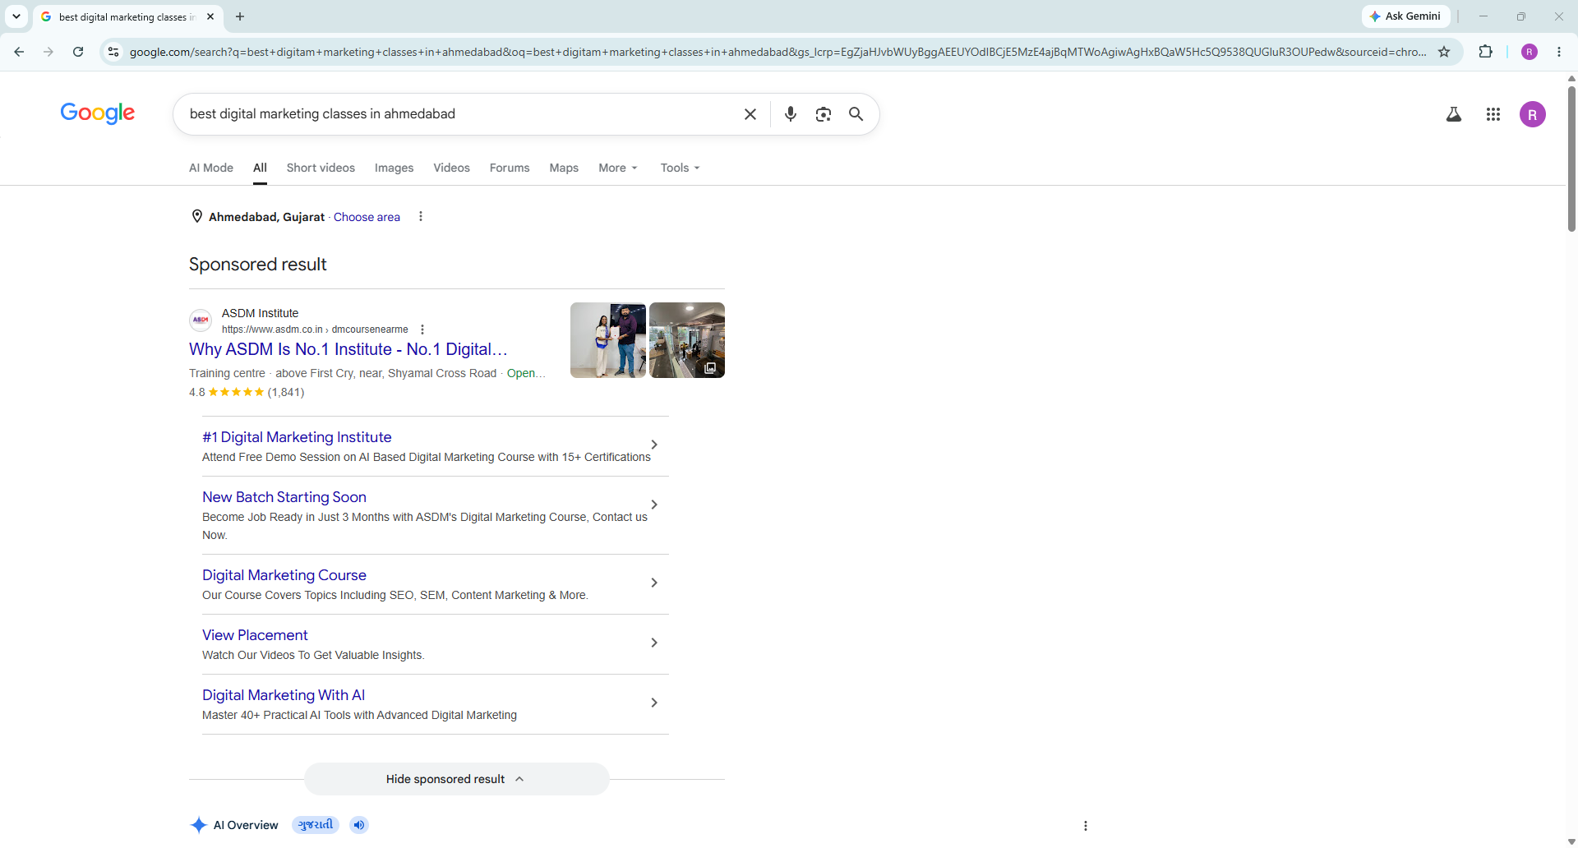
- 8 organic results were shown in Page-1.
- No paid ads appeared after searching : 'apply for Aadhaar card online' because it is on government site and Government sites usually do not show commercial ads because their purpose is to provide public services, not earn advertising revenue that’s why no ads were shown.
- Searched best cafes, colleges and clothing style for women.
- 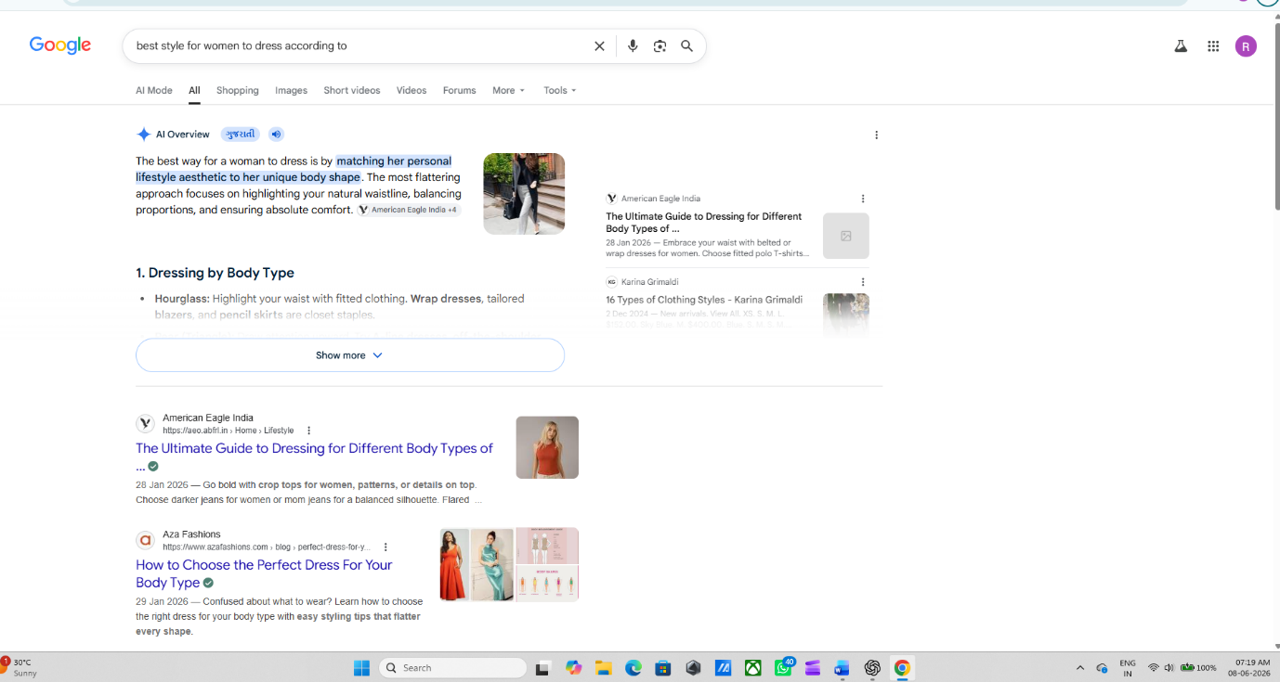

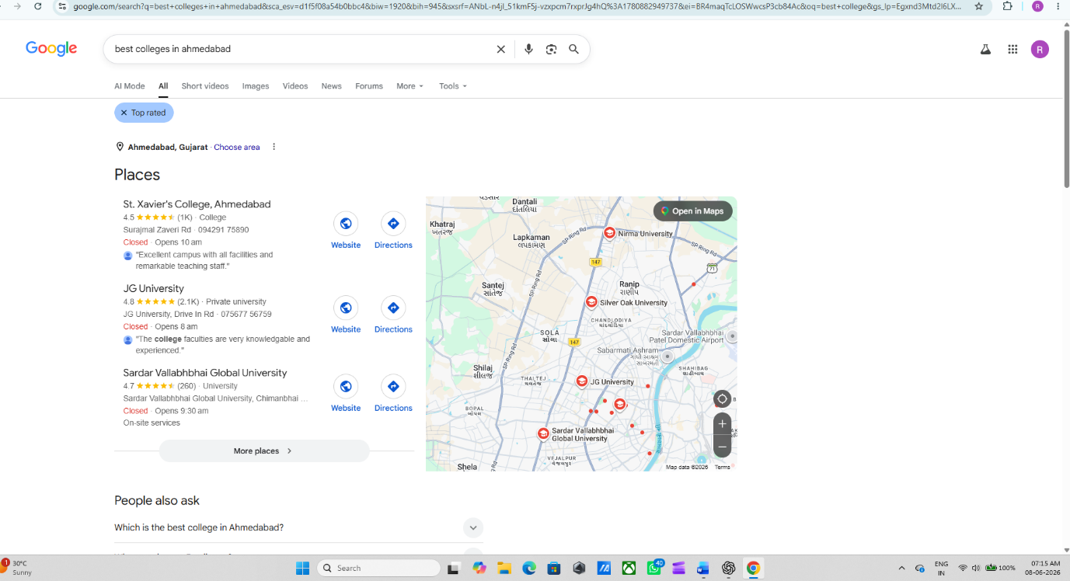

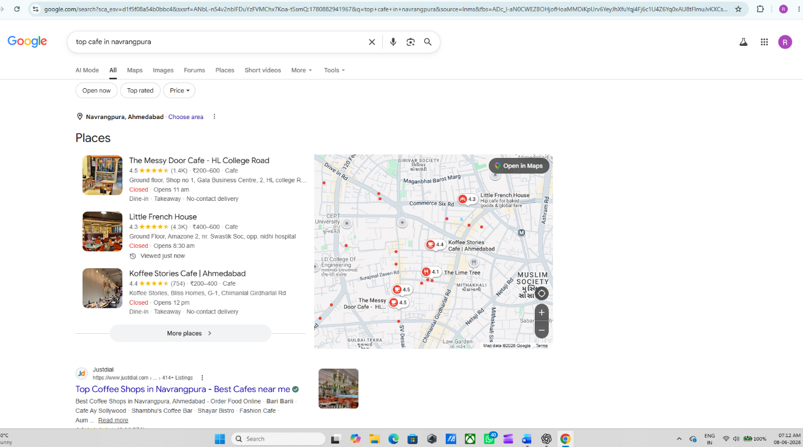
Conclusion = All results are organic they are not sponsored.
- (Bonus) = Bing’s answer is completely different from chrome.

PRACTICAL TASK: L2 — Analyse 3 SEO Job Descriptions on LinkedIn
- Open LinkedIn on your phone or laptop and search: 'SEO Specialist India'.
- Filter by: Location = India, Experience Level = Entry Level / Associate.
- Open 3 different job descriptions from 3 different companies.
- For each JD, note down:
(a) Company Name & Industry,
(b) Required Skills Listed,
(c) Tools mentioned = (Ahrefs, SEMrush, Google Analytics?),
(d) Salary range if mentioned =

- Identify: Which skill is mentioned in all 3 job descriptions? That is your priority skill to learn.
- Write a 100-word reflection: 'What gap exists between my current skills and the job requirements?'
- Bonus: Use LinkedIn's 'Easy Apply' feature to bookmark jobs you'd like to apply for in 6 months.

ANSWER:-
9. Opened LinkedIn in laptop.
10. 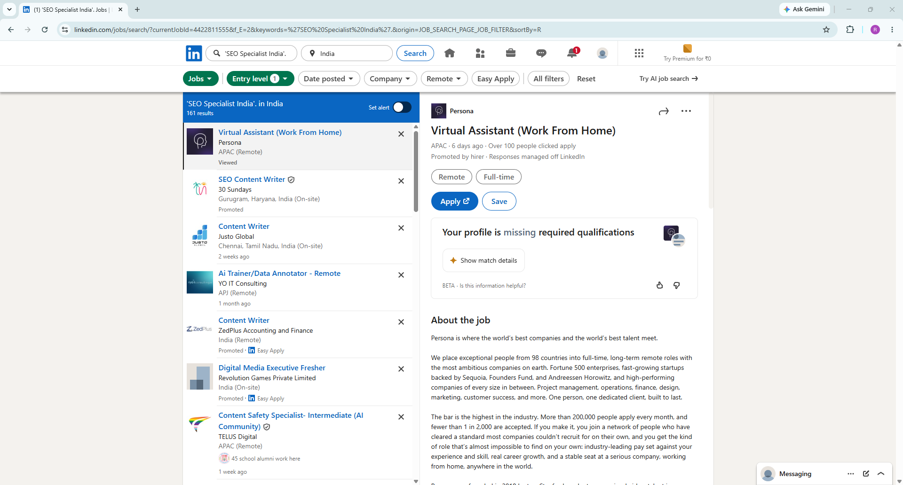

11. a. 30 Sundays
b. YO IT Consulting
c. Value creed
12.
<1> - 30 SUNDAYS
(a)Company Name & Industry = 30 Sundays and SEO content writer.
(b) Required Skills Listed = Excellent English writing and research skill , ability to simplify complex travel information into engaging content and passion for travel and storytelling.
(c) Tools mentioned = SEMrush, Google Search Console, Google Analytics
(d) Salary range if mentioned = Salary wasn’t mentioned.

<2> - YO IT Consulting
(a) Company Name & Industry = YO IT Consulting and AI Evaluation Specialist
(b) Required Skills Listed = Exceptional reading comprehension and acute attention to detail.
- Strong observational skills with excellent aesthetic or editorial judgment.
- Ability to think critically and deliver consistent, high-quality evaluations in ambiguous scenarios.
- Excellent written and verbal communication skills.
- Comfort working across various content types and evaluation guidelines.
- Strong sense of ownership, reliability, and commitment to delivering high-quality work for the customer's team.
- Open-minded approach to learning and quickly adapting to new workflows.
(c) Tools mentioned =Tools were not mentioned.
(d) Salary range if mentioned = Salary wasn’t mentioned.

<3> - Value creed
(a) Company Name & Industry = Value creed and Social Media Marketing Specialist
(b) Required Skills Listed = Strong understanding of social media platforms, digital trends, and audience engagement strategies
- Creative mindset with the ability to generate fresh and engaging content ideas
- Good communication and content writing skills
- Basic understanding of branding, marketing, and visual storytelling
- Ability to follow instructions, adapt quickly, and work collaboratively with teams
- Understanding of current internet culture, trending formats, memes, and social media algorithms
- Familiarity with Canva, basic editing tools, or content creation platforms is a plus
- Strong organizational and time management skills
- Ability to work in a fast-paced and creative environment
- Prior experience in content creation, social media handling, or digital marketing is preferred.
(c) Tools mentioned =Familiarity with Canva, basic editing tools, or content creation platforms is a plus
(d) Salary range if mentioned = Salary wasn’t mentioned.

13. Writing Skill and Good Communication skill is required in all these three job description.

14. The gap between my current skills and the job requirements is that I am still learning SEO and gaining practical experience. I know the basic concepts of SEO like keywords and all but I need to improve my knowledge of advanced SEO techniques and tools. Many jobs require hands-on experience and a deeper understanding search engine rankings. To reduce this gap, I am constantly learning SEO. With more training and experience, soon I will be able to meet the job requirements more confidently.

PRACTICAL TASK: L3 — Product Search Observation on Amazon India

Open Amazon.in on your browser.

Search for any product you've purchased recently (e.g., 'running shoes for men', 'protein powder', 'laptop bag').

Observe the TOP 3 organic results (not 'Sponsored'). For each, note: (a) Product Title — how many keywords are in it? (b) Number of ratings and average star ratings, (c) Price and delivery promise, (d) Whether it has 'Amazon's Choice' badge.

Now search the SAME product on Google. Do the same Amazon listings appear? Or different ones?

Try Google Lens: Point your phone camera at any product around you. See what Google finds.

Search a question by voice: Ask 'Hey Google, what is the best Wi-Fi router under 2000 rupees in India?'. Observe the spoken answer Google gives.

Document: Take screenshots of Amazon results, Google results, and Google Lens output.

Write 5 observations: What differences do you notice between how Amazon and Google rank products?

ANSWER-
- Opened amazon.in in browser.
- Searched ‘laptop’.
- Three organic results were,
1-Dell 15 laptop
2- Lenovo V15
3- Dell model 5420
1-Dell 15 laptop
: (a) Product Title — how many keywords are in it? =
Dell 15 (Previously Inspiron) Laptop, 14th Gen Intel Core i3/Core 3 100U Processor, 8GB DDR4, 512 SSD, 15.6" FHD 120Hz IPS 250 nit Display, Win 11 + Office H&S 2024, Carbon Black, Thin & Light 1.63Kg , keywords- only one (laptop)
(b) Number of ratings and average star ratings
=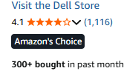
(c) Price and delivery promise =
M.R.P.: ₹48,692.00
Inclusive of all taxes
EMI starts at ₹1,599. No Cost EMI available
FREE delivery Thursday, 11

(d) Whether it has 'Amazon's Choice' badge.
=It has
2- Lenovo V15
(a)Product Title — how many keywords are in it? = Lenovo V15 G4 AMD Athlon Silver 7120U Laptop 8GB LPDDR5 Ram, 512 GB SSD PCIe, Windows 11 Lifetime Validity,15.6" FHD Screen, AMD Radeon 610M, Silver, 1 Year Brand Warranty
- Number of ratings and average star ratings

= 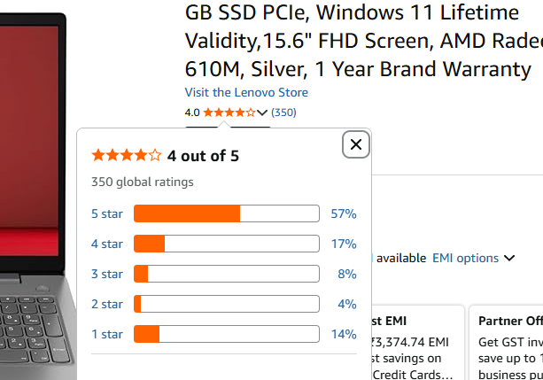
(c) Price and delivery promise = 42,999.00
FREE delivery Thursday, 11 June. Details
Or fastest delivery Tomorrow, 9 June. Order within 1 hr 17 mins.
(d) Whether it has 'Amazon's Choice' badge.
=
It has
3- Dell model 5420
(a)Product Title — how many keywords are in it? = 𝗗𝗲𝗹𝗹Laptop Model 5420 | 𝗜𝗡𝗧𝗘𝗟i5 11th Gen Processor |8GB DDR4 RAM |256GB SSD |14" FHD Display | Win10 | A+ Condition Laptop (Refab)
(b) Number of ratings and average star ratings
= 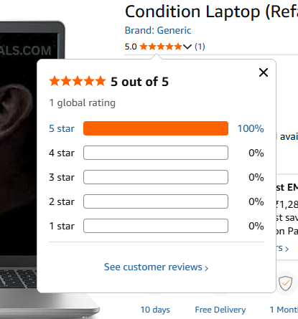
(c) Price and delivery promise = 39,490.00
FREE delivery Sunday, 14 june
(d) Whether it has 'Amazon's Choice' badge = It doesn’t have

19 - Google and Amazon.in have different answers or the list that appears in google does not match with amazon they both are different from each other.

20 – Done opening google lens and point camera at product(laptop) near me.

21- 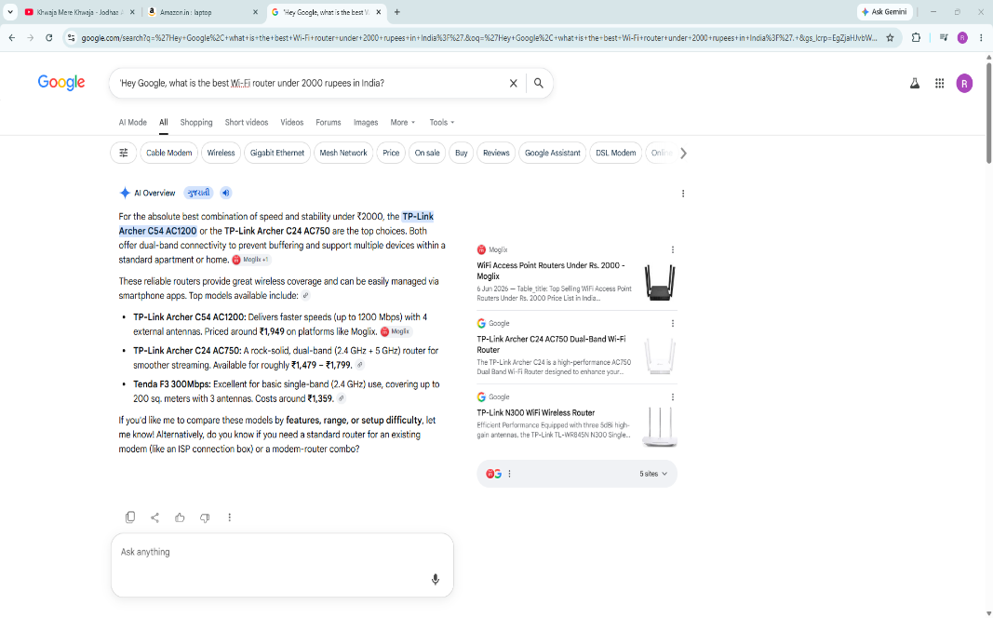
This is what google replied.

22
22.1 google- 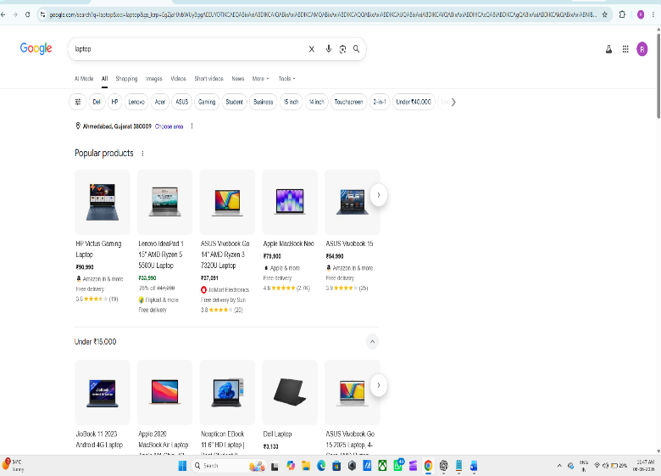
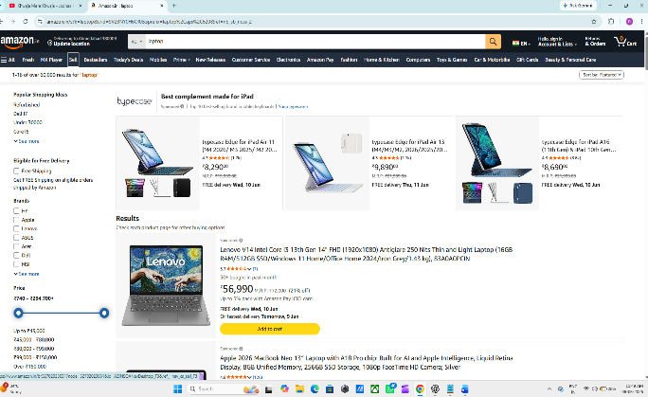
22.2 amazon
22.3 Google lens 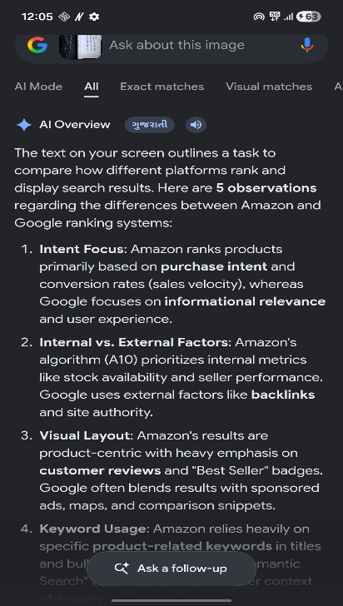

23- 1. Amazon ranks products based on what people are most likely to buy, while Google ranks based on what is most relevant to the search.
2. Amazon gives higher rankings to products with strong sales, hile Google focuses more on keywords and content quality.
3. Customer reviews have a bigger impact on product rankings on Amazon than on Google.
4. Amazon promotes products through marketplace sales performance, while Google uses both SEO and ads.
5. Amazon rewards well-optimized product listings, while Google also considers the reputation of the website selling the product.

PRACTICAL TASK: L4 — AI SEO Analysis Task

Open ChatGPT (free version) in one browser tab and Google Gemini in another.

Ask BOTH: 'What is SEO in 2026? Explain in detail for a beginner in India.'

Compare the two answers: (a) Which one is more detailed? (b) Does either mention India-specific examples? (c) Which tools or concepts does each emphasize?

Now ask both: 'What websites or sources are you using to answer SEO questions?' Observe which Indian websites (if any) are being cited.

Visit one of the cited websites and analyze: (a) What makes their content authoritative? (b) Do they have author bios? (c) Do they use structured data (Schema)?

Search on Google: 'What is technical SEO?' — Does an AI Overview appear? Take a screenshot.

Write a 300-word analysis: 'How is AI changing the way we should create SEO content in India?' Include at least 3 specific AI SEO strategies you plan to use.

Bonus: Use the prompt above to get ChatGPT to evaluate your own answer and suggest improvements.
ANSWER –
24. Opened ChatGPT and Gemini.
25. Asked them about SEO
26. (a) ChatGPT is more detailed compared to Gemini.
(b) ChatGPT mentioned little bit about some Indian cities while Gemini did not mentioned India.
(c) ChatGPT = Keywords, on-page SEO, off-page SEO, technical SEO, local SEO, content marketing and backlinks.
Gemini = Learning and Study Suite and Deep Research Capabilities.
27. There isn’t any Indian website they are using for their sources.
28. There is not citied website of India they use for their sources.
29. 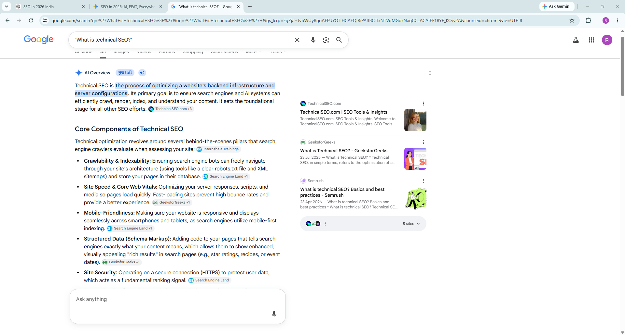
30. AI (Artificial Intelligence) is changing the way we create SEO content in India. Earlier, people focused mostly on adding many keywords to their articles so that websites could rank higher on Google. Today, AI helps search engines understand what people really want to know. Because of this, content creators must focus on giving useful and clear information instead of just repeating keywords.
One AI SEO strategy I plan to use is AI keyword research. AI tools can find the exact words and questions people are searching for online. This helps me create content that matches what users want and increases the chances of ranking higher on search engines.
The second strategy is AI content optimization. AI tools can check whether my content is easy to read, well-structured, and covers the topic properly. They can also suggest better headings and related topics to include. This helps create high-quality content that both users and search engines like.
The third strategy is AI-based content personalization and localization. India has many languages and different types of audiences. AI can help identify local trends and popular topics in different regions. I plan to use AI to create content that is more relevant to specific Indian audiences, making it more useful and engaging.
AI can also save time by helping with tasks such as creating content outlines, checking grammar, and analysing website performance. However, human creativity is still important. AI can provide ideas and suggestions, but people are needed to add personal experience, accuracy, and originality.
In conclusion, AI is making SEO content smarter and more user-focused. To succeed in India's digital world, content creators should use AI tools while continuing to create helpful, trustworthy, and easy-to-understand content for their audience.

